HELPING HANDS

Finance Department (FD)

1. **Objective**

* Collect and distribution of helping hands fund in effective manner.

1. **Functions of FD**
   1. Collection of Money
   2. Allocations and distribution of Money
   3. One time investment and Stationary
2. **Structure of Finance Department (FD)**

**Faculty Members**

**Joint Secretary of FD:**Sunil Raiyani, Dept. of Civil (sunil.raiyani@rgukt.in)

**Student EC Members**

|  |  |  |  |  |  |
| --- | --- | --- | --- | --- | --- |
| **Name** | **ID** | **Batch** | **Branch** | **E-mail** | **Phone .no** |
| J. Sai Teja | N090492 | E-3 | Mech | saiteja.jutru@gmail.com | 9052558980 |

1. **Process of Functioning:**

**Collection of Money**

* Collection of money will be happen most probably three# way.

1. Collection of the money from the students every week on Tuesday at study hours. If that is holiday, it will be done on the next of that day i.e. Wednesday.
2. Selling the used rough books by students every year.
3. Collection of the money from the drop box and donor.

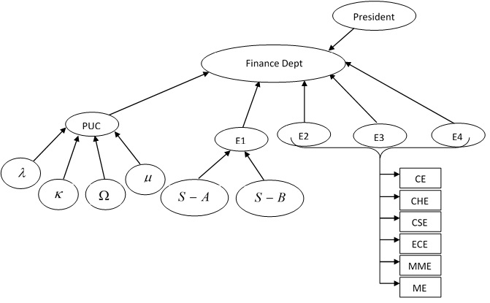

**Descriptions**

1. **For PUC Class**

* Each class have HCR (Helping Hand Class Representatives – one boy and one girl,), they have to collect the fund from the classroom students and hand over to the head of HCR () by keeping the records. These head HCR are the member of HCR only.

Head HCR () will collect the money from the each class HCR

* PUC EC member will collect the money from the head HCR and will hand over the Finance Dept by keeping the records and these records will be displaced every month on website.

|  |  |  |  |  |  |
| --- | --- | --- | --- | --- | --- |
| Date | Collected  Amount | Cluster | Sign of head HCR | Sign of PUC EC Member | Sign of Finance Dept |

1. **For E1 Class**

* Each class has HCR (Helping Hand Class Representatives – one boy and one girl for each class in Section A and Section B), they have to collect the fund from the classroom students and hand over to the head of HCR (Section A – 2 students and Section B – 2 students). These head HCR are the member ofHCR only.

Head HCR (Section A – 2 and Section B – 2) will collect the money from the each class HCR

* E1 EC member will collect the money from the head HCR and will hand over the Finance and Treasurer by keeping the records and these records will be displaced every month on website.

|  |  |  |  |  |
| --- | --- | --- | --- | --- |
| Date | Collected  Amount | Sign of head HCR | Sign of E1  EC Member | Sign of Finance Dept |

1. **For E2, E3, E4 Classes**

* Each class have HCR (Helping Hand Class Representatives – one boy and one girl, CE (E2-6,E3-10,E4-12)*, CHE (E2-2,E3-4,E4-6)*, CSE (E2-6,E3-12,E4-12)*, ECE (E2-6,E3-12,E4-12)*, MME (E2-4,E3-8,E4-8)*, ME (E2-6,E3-12,E4-12)* ), they have to collect the fund from the classroom students and hand over to the head of HCR (CE E2/E3/E4– 2, CHE E2/E3/E4– 2, CSE E2/E3/E4– 2, ECE E2/E3/E4– 2, MME E2/E3/E4– 2, and ME E2/E3/E4– 2).

Head HCR will collect the money from the each class HCR

* E2,E3,E4 EC Member will collect the money from the head HCR and will hand over the Finance and Treasurer by keeping the records and these records will be displaced every month on website.

|  |  |  |  |  |
| --- | --- | --- | --- | --- |
| Date | Collected  Amount | Sign of head HCR | Sign of E1  EC Member | Sign of Finance Dept |

**\*subjected to change in future according to the no of students and classes allocated to them.**

**#subjected to change according to conditions and availability of source of incomes.**

**Allocations ofMoney**

Money reached from various sources like collection from the students, selling of used rough books, collection from the drop box and donation per year, out of 100 % collection 90% money will be utilized for various activities remaining 10% money will be keep as a treasurer and will utilize at the time of most emergency only. Utilization of 90% money is the following manner:

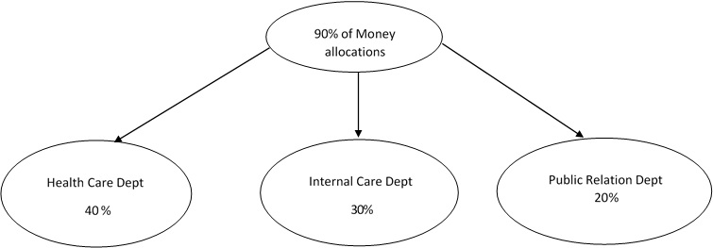

**One Time Investment and Stationary**

One time investment (like purchase of washing machine, printer etc…) and purchase related to stationary with the proper approval of EC members.

* Stationary expenditure (like mobile recharge, cartridge filling etc…) money if more than Rs. 500 then the Joint secretory of FD need to arrange EC meeting **after consulting with general secretary** for necessary approval.

**For the Joint secretory of FD**

* Finance Dept need to release the fund by keeping the record in proper category wise (like HCD, ICD, PRD etc…).
* If Joint secretory strongly feel that further scrutiny (in the case of exceeding the budget) is needed then he/she may take necessary steps in this regard with consultation of President, Vice President and General Secretary.